Working Directory

Definition
# Source: AI Source: Provided by: [Data Path: Persons Table -> ID Column: 1, Name_En Column: Motasem Essam] -> From: [ChatGPT] on [2/15/2026]
The Working Directory (Working Tree or Workspace) is the current folder on your computer where you are actively editing project files.
It is the place where you create, modify, and delete files before saving them into Git history.

Is Working Directory being main folder for all project or folder that has files you work on it only?

Short answer:
# Source: AI Source: Provided by: [Data Path: Persons Table -> ID Column: 1, Name_En Column: Motasem Essam] -> From: [ChatGPT] on [2/15/2026]
The Working Directory is the main project folder — including all files and subfolders you are working on.
The Working Directory = the whole project folder, not just one file.

Example:
# Source: AI Source: Provided by: [Data Path: Persons Table -> ID Column: 1, Name_En Column: Motasem Essam] -> From: [ChatGPT] on [2/15/2026]
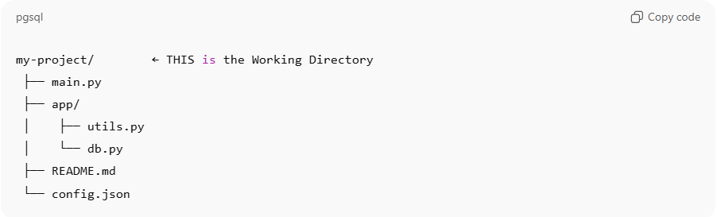
my-project/ ← THIS is the Working Directory
├── main.py
├── app/
│ ├── utils.py
│ └── db.py
├── README.md
└── config.json

Everything inside my-project is part of the Working Directory:
- All files
- All subfolders
- Anything you edit, create, or delete

Important notes
# Source: AI Source: Provided by: [Data Path: Persons Table -> ID Column: 1, Name_En Column: Motasem Essam] -> From: [ChatGPT] on [2/15/2026]
- It is the top-level project folder where .git exists
- Git watches all files inside it (recursively)
- You can work on one file or many — all are still inside the same Working Directory
- If you open the project in VS Code → the opened folder = Working Directory

Simple idea
# Source: AI Source: Provided by: [Data Path: Persons Table -> ID Column: 1, Name_En Column: Motasem Essam] -> From: [ChatGPT] on [2/15/2026]
Working Directory = the live version of your project you are working on right now.

How it fits in Git workflow
# Source: AI Source: Provided by: [Data Path: Persons Table -> ID Column: 1, Name_En Column: Motasem Essam] -> From: [ChatGPT] on [2/15/2026]
Git has 3 main areas:
- Working Directory → where you edit files
- Staging Area (Index) → where you prepare changes
- Repository (.git) → where Git permanently stores commits
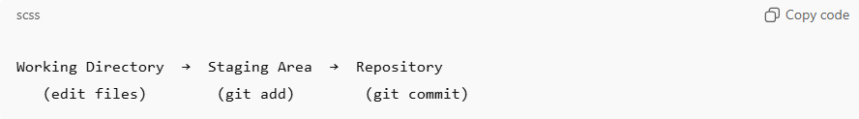
Working Directory → Staging Area → Repository
(edit files) (git add) (git commit)

Example
# Source: AI Source: Provided by: [Data Path: Persons Table -> ID Column: 1, Name_En Column: Motasem Essam] -> From: [ChatGPT] on [2/15/2026]
You change a file:
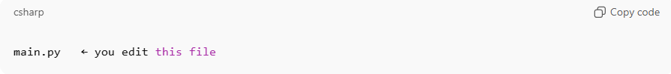
main.py ← you edit this file
Git sees it as modified in the Working Directory, but not saved in history yet.
To save it:
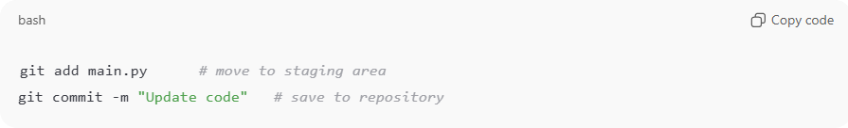
git add main.py # move to staging area
git commit -m "Update code" # save to repository

Key points
# Source: AI Source: Provided by: [Data Path: Persons Table -> ID Column: 1, Name_En Column: Motasem Essam] -> From: [ChatGPT] on [2/15/2026]
- Contains actual project files
- Files here can be:
  - Modified
  - New (untracked)
  - Deleted
- Changes are not permanent until you commit
- You interact with it using normal file editing (VS Code, Notepad, etc.)

Quick comparison
# Source: AI Source: Provided by: [Data Path: Persons Table -> ID Column: 1, Name_En Column: Motasem Essam] -> From: [ChatGPT] on [2/15/2026]
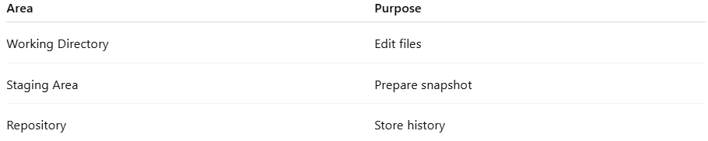
Area | Purpose
Working Directory | Edit files
Staging Area | Prepare snapshot
Repository | Store history

